
NMAM INSTITUTE OF TECHNOLOGY, NITTE
Nitte, Karkala-574110

Assignment
ON
AI-BASED STUDY PLANNER FOR STUDENTS

Submitted to
Dr. JASON ELROY MARTIS
Professor

In the partial fulfilment of requirements for the award of degree

BACHELOR OF ENGINEERING
IN

INFORMATION SCIENCE AND ENGINEERING

by
ARFA, NNM24IS038

Abstract
The management of time for studies is a challenge for students in today’s academic world. There are many courses, exams, assignments, and other activities. If students do not have a proper plan, it adds more pressure. The conventional approach of using a plan with reminders is not effective for time system would be more appropriate using the Incremental and Spiral Models of the SDLC approach rather than the Waterfall Model.

The proposed system is effective for better management of time by students. It improves productivity and helps students plan their schedules better. The proposed study has also revealed that an appropriate choice of software development life cycle is important for developing flexible, efficient, and effective software.
management for studies.

To overcome this challenge, an AI-Based Study Planner for Students is proposed. The proposed system would utilize software algorithms to process student input and generate a study plan. It would remind students of exams and assignments. It would also track the plan and provide suggestions to facilitate efficient studying.

This study also identifies and evaluates various software development life cycle (SDLC) approaches, namely Waterfall, Incremental Development, and Spiral Models. It has been proposed that the proposed [1][2]

GITHUB REPOSITORY LINK:

https://github.com/ArfaBN/AI-BASED-STUDY-PLANNER-FOR-STUDENT

Introduction
In the current learning environment, a student has to perform several activities such as attending classes, completing assignments, preparing for examinations, and participating in extracurricular activities. A student should plan and organize himself or herself properly to effectively manage all these activities. However, it is difficult for a student to plan and organize himself or herself properly, and it affects the student's performance and results.[1][2] A student may not perform well if he or she does not plan and organize himself or herself properly.
Traditionally, a student could use a time table or an app to plan and organize himself or herself properly. These tools are not sufficient to plan and organize properly.

Currently, software and Artificial Intelligence (AI) technologies are advancing rapidly, and it is now possible to develop efficient apps using AI technology. An AI-Based Study Planner for Students is an app that helps a student plan and organize himself or herself properly.[3]
The objective of the assignment is to study and compare three Software Development Life Cycle (SDLC) models, such as the Waterfall Model, the Incremental Model, and the Spiral Model, with respect to developing an AI-Based Study Planner for Students.[1][2] The assignment also includes the methods to follow when developing software using the above models and improving the developed software using the models. The assignment also includes the importance of requirements engineering in developing good software.
The assignment is related to the concepts studied in Unit-I, such as Software Engineering, Software Development Life Cycle Models, and Requirements Engineering.
The assignment presents an example of an educational software system and explains the importance of developing good software using an appropriate software development process and software process model. The assignment also explains the importance of choosing the right software process model to develop efficient software systems.

Problem Statement
The main aim of this project is to explore and compare different software development life cycle models while developing an intelligent Study Planner for students. The project aims to assist students in planning their studies through the creation of a personalized study planner timetable. In a way, the project aims to evaluate different software development life cycle models in terms of their ability to facilitate system analysis, development, risks, and enhancements in the creation of an intelligent software application for student planning.[1][2]
Tasks to be Solved
The aim of this assignment is to identify which is the best SDLC model to be used to design an AI-Based Study Planner for Students. It is intended to enlighten how requirement analysis, system design, and software risk management come together. [1][2] The proposed system is meant to assist students in planning their studies, effectively manage their time, and be reminded of important academic events. The assignment is aimed at enhancing an understanding of software development processes and how it applies to designing an intelligent student support system.
Expected Outcomes
The system will comprise a software application that will depend on the information the student feeds into it, such as the subjects, exams, and amount of time available. The effectiveness of the system will depend on the accuracy of the information fed into it. The development of the system may also depend on factors such as the availability of resources, time constraints, and technical issues. Furthermore, it is assumed that the student has access to a device, whether a smartphone or computer, which will be used as a medium for accessing the study planner our system has to offer.
Constraints and Assumptions
The system will be a software-based application, and it will be dependent upon user inputs, i.e., subjects, exam dates, and available study time. The effectiveness of the system will be dependent upon the accuracy and completeness of the information provided by the student. The development of the system may be restricted by factors like available development resources, time constraints, and technical complexities. It is also assumed that users will have access to digital devices like smartphones or computers, which will be used as a medium for using the study planner application developed by our system. The system will be required to perform efficiently, securely, and with ease of use.[1]
Dataset Description
System Name
AI-Based Study Planner for Students
This project presents an AI-based educational tool aimed at helping students effectively organize their academic life. The tool is specifically designed to plan and organize the student's study time, prioritize the subjects, and send reminders regarding important academic events such as assignments and examinations. [3] The student may provide the system with relevant information regarding the subjects, examination dates, study time, and academic goals. The system requirements.
Data Source
The system would mostly depend on the data provided by the would then generate the most appropriate study plan according to the student's
student. The student would provide relevant information regarding the subjects, examination dates, study time, and deadlines of the assigned tasks. The AI system would then generate the most appropriate study plan according to the student's requirements.[3] The system would also be able to track the student's study time and efficiency.
Data Collected
The system collects different types of data associated with academic planning. The types of data include information about subjects, exam dates, assignment due dates, and the number of available study hours. It also includes data about the student’s study progress, tasks completed, and tasks to be completed. The data includes relevant context, such as dates and times, to track the student’s progress over time. The data is updated to ensure that the student’s study schedule matches their current academic situation.
Data Processing
The data collected by the system is processed to create an efficient study plan. The first step in processing the data is to validate the data, correcting any missing or wrong information. Once the data is validated, the system analyzes the data to create a well-structured timetable. The timetable is designed to ensure efficient study sessions. The system can also refresh the timetable if new tasks or exams are introduced.[3]

Methodology / Process Models
Waterfall Model
The Waterfall Model follows a linear path, which means we complete one phase before moving on to the next. This model is used in projects where requirements are clearly identified at the beginning of the project, and these requirements are unlikely to change. In our project, we will start with requirement analysis, which will allow us to clearly identify the requirements that our system needs to fulfill. These requirements include features such as timetable generation, reminders, etc. The second phase will be system design, followed by system development. The drawback of the Waterfall Model is that, although it is easy to understand and follow, once the project is complete, changes can be difficult.[1][2]
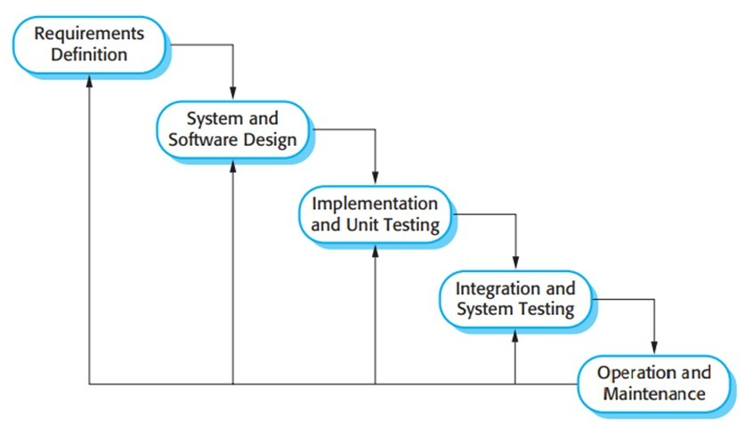

Incremental Development Model
Instead of developing the whole system, we are developing it piece by piece.[1][2] As we move to the next stage, more and more features are being added to the system.
The first stage involves entering subjects and dates of exams. The second stage involves generating a timetable according to the number of hours we have to study.[1]
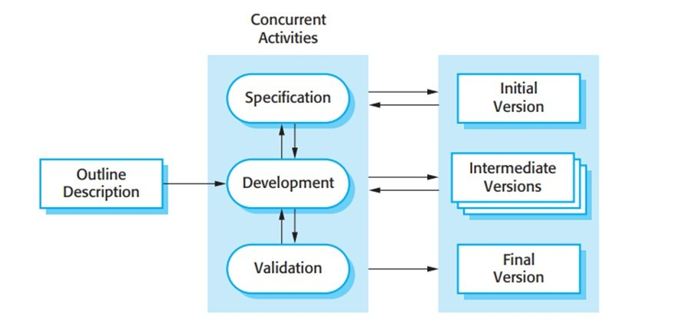
Spiral Model
The Spiral Model combines the elements of iterative development and risk analysis. This model is best for use in complex systems that may have changing requirements. In the development process, the spiral model includes elements of planning, risk analysis, development, and evaluation.[2] In the AI-Based Study Planner project, the requirements will be set, problems will be identified, the required features such as scheduling and reminders will be developed, and user feedback will be evaluated. This is a suitable model for the AI-Based Study Planner development process.[2]

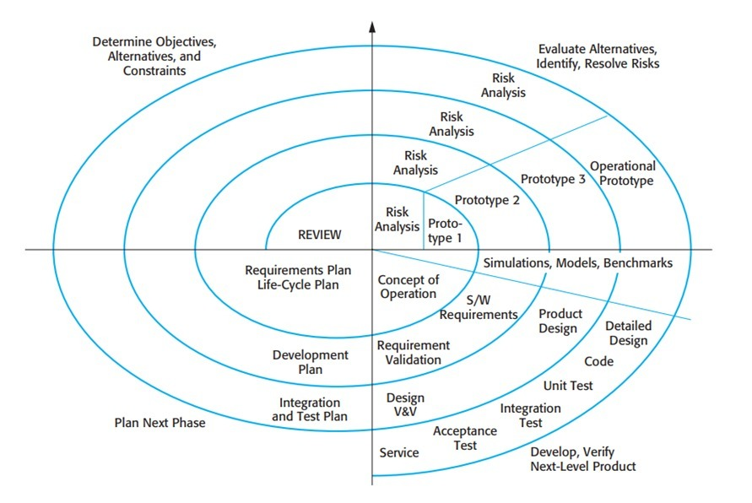
Implementation Details
The components include user input component, generation of a timetable component, reminder component, progress tracking component, and user interface component. The students will be required to input their subjects, exam dates, and the number of hours spent studying. The information will be stored in the database. The system will then generate a study plan, and tests will be carried out to ensure that it performs as desired.[1]

Experiments Performed
There were also tests conducted to check the efficiency of the AI-Based Study Planner. The tests included varying the number of subjects, the number of exams, and study hours in the timetable generation. In the reminder generation, future events were simulated. The reliability tests were conducted by using the system repeatedly.[1]
Results and Analysis
It developed study plans that were clear and well-organized using the provided information. It helped to enhance the management of the study time. It reminded the user to be punctual for events such as examinations and assignments.[3]
Discussion
The experiments revealed that automated study scheduling can really increase the effectiveness of students' time management. Study blocks were allocated optimally, and timely reminders ensured that deadlines remained at the front of one's mind, minimizing the possibility of missing them. The study planner also facilitated real-time updates, which meant that a student could change their plan as soon as a new assignment or exam was announced.[3]
From the above discussion, it is quite obvious that different software development models can be more or less suitable. The Waterfall Model was easy to implement because of its rigid, structured nature. However, the Waterfall Model was also less effective because of its inability to cope with changes. [1][2] The Incremental Model was also quite effective because of the stepwise implementation of the system.[1] The Spiral Model was found to be the most effective, as it facilitated continuous improvement through continuous risk analysis.[2]
Though there were problems faced during the implementation of the system, such as designing an equitable scheduling algorithm and dealing with different inputs from users, the system was found to be quite viable after experimentation. This, therefore, points to the fact that an efficient software development life cycle, like the Spiral Model, is the key to an efficient intelligent study planning system.[1][2]

Requirements Engineering [1][2]
Functional Requirements
Functional Requirements

- Users (students) can enter their subjects and course information.
- Users can enter dates of upcoming exams and assignments.
- Users can log in the amount of time they have for studying.
- Timetables for studying are automatically generated.
- Reminders are automatically sent for upcoming exams and assignments.
- Study timetables track study progress and study session logs.
- User information is collected at regular intervals.
- Study information is saved in a database.
- Study information is recorded for real-time analysis and historical analysis.
- Schedules are analyzed to ensure accuracy.
- Users are notified of important tasks and deadlines.
- Users can view their timetables.
- Users can view visual representations of study timetables.
- Users can modify timetables from remote locations.[1][2]
Non-Functional Requirements
- Timetables are automatically generated with minimum processing time.
- The system can operate with minimum downtime.
- User information is saved securely.
- The saved information cannot be accessed by unauthorized users.
- The system can efficiently run on most commonly used devices.
- The system can handle a large number of users.
- Timetables can be accurately generated.
- The system can operate with minimum downtime even with minor errors in input information.
- The system is easy to use and understand for students.
- The system can operate for a long time without frequent shutdowns.
- The software modules can be easily maintained and updated.[1][2]
- The system can run on most commonly used browsers and operating systems.

Requirements Validation Strategy

Validation of the requirements can be done through gathering information from users, testing prototypes, and performance testing.[1][2]
Limitations and Future Work
Limitations
  - The student must input the required information accurately and comprehensively.
  - Any wrong or incomplete information provided would reduce the quality of the study plan generated.[1]
  - If reminders and cloud storage are used, access to the Internet is required.
  - If there are any sudden changes to the date of the exams or plans of the student, manual adjustments to the timetable are required.
  - The system would be best used when the student has kept their study plans updated.

Future Work
• Develop a mobile app that allows students to access their plans anywhere and anytime.
• Integrate it with academic calendars to ensure that exam and assignment dates are automatically updated.
• Include a dashboard that allows students to monitor their progress across different subjects over a period of time.
• Enhance reminders to include smart reminders that can be tailored to meet individual students' study needs.
• Use cloud technology to ensure that students' study plans are synchronized across different devices.
• Include AI predictions to help students improve their plans and identify areas to focus on.[3]
• Include advanced features to enhance the effectiveness and scalability of the system.

Conclusion
This assignment helped me understand the practical use of different models of the software development life cycle. It was useful in creating a practical example of the use of the models in a real-life scenario, such as the development of an AI-Based Study Planner for Students. This app will help students schedule their plans, use their time effectively, and remind them of important events. It will also help them save time by creating a general structure for their plans automatically.
Out of the models discussed, the Waterfall Model provided a general guideline but was not flexible. The Incremental Model was useful because it helped users use the features of the app as they were developed. The Spiral Model was the best for the app because it ensured constant improvement and risk management, which is important due to the changing needs of the users.[1][2]
References
[1] I. Sommerville, Software Engineering, 10th edition, Pearson, 2016.
[2] R. Pressman and B. Maxim, Software Engineering: A Practitioner’s Approach, McGraw-Hill, 2019.
[3] Khan, A., et al. (2023). Intelligent Study Planning Systems: A Review. Journal of Educational Technology."

Declaration on Academic Integrity

I confirm that my project, “AI-Based Study Planner for Students,” is my original work, and I have done it after following the academic integrity guidelines of my academic institution.

I confirm that I have not cheated or behaved in a dishonest manner in any form, which includes but is not limited to, plagiarism, fabricating information, or using other people’s work without proper acknowledgment and permission.

I understand the reasons why honesty, transparency, and integrity are important in school assignments. I also understand that there are consequences if I violate these guidelines.

My project is not submitted for any other degree, diploma, or certificate course in whole or in part.

I accept full responsibility for the authenticity and originality of my project.

Signature: _____________

Date: 15-02-2026

